Summary: Nervous System Name:_______________________
Nervous System
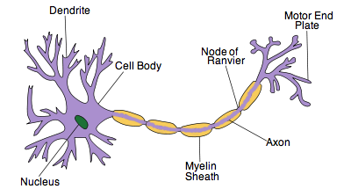
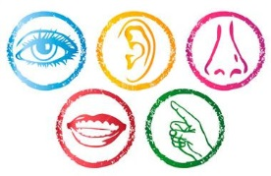
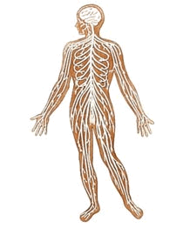
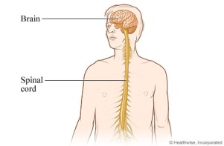
Autonomic Nervous System
Somatic Nervous System
Sympathetic Nervous System
Definition:

Examples
Parasympathetic Nervous System
Definition:

Examples

Peripheral Nervous System
Central Nervous System

